The Parish & Borough Church of St Mary,
Harrow on the Hill

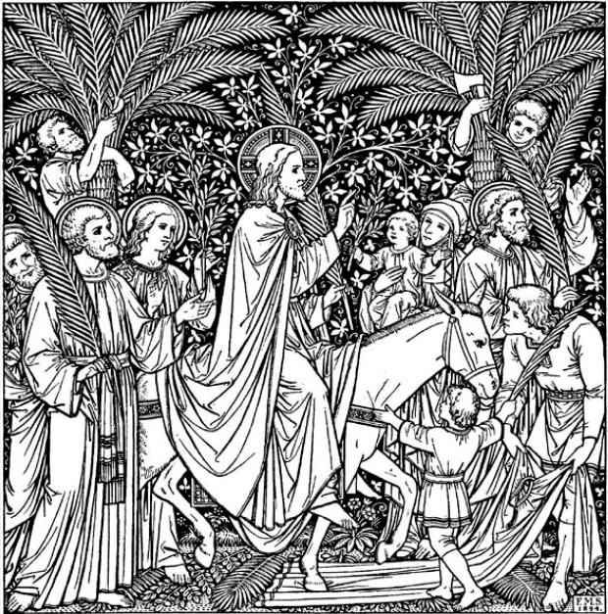

PALM SUNDAY 2020
Sunday 5 April

COMMEMORATION OF THE LORD’S ENTRY INTO JERUSALEM

The Greeting

Hosanna to the Son of David, the King of Israel. Blessed is he who comes in the name of the Lord. Hosanna in the highest.

Grace, mercy and peace from God our Father and the Lord Jesus Christ be with you
and also with you.

Introduction

Dear brothers and sisters in Christ, during Lent we have been preparing by works of love and self-sacrifice for the celebration of our Lord’s death and resurrection. Today we come together to begin this solemn celebration in union with the Church throughout the world. Christ enters his own city to complete his work as our Saviour, to suffer, to die, and to rise again. Let us go with him in faith and love, so that, united with him in his sufferings, we may share his risen life.

Please hold up the palms and your palm crosses while the prayer of blessing is said

God our Saviour, whose Son Jesus Christ entered Jerusalem as Messiah to suffer and to die; let these palms be for us signs of his victory and grant that we who bear them in his name may ever hail him as our King, and follow him in the way that leads to eternal life; who is alive and reigns with you, in the unity of the Holy Spirit, one God, now and for ever. Amen.

The Palm Gospel

Hear the Gospel of our Lord Jesus Christ according to St Luke
Glory to you, O Lord.

When they had come near Jerusalem and had reached Bethphage, at the Mount of Olives, Jesus sent two disciples, saying to them, “Go into the village ahead of you, and immediately you will find a donkey tied, and a colt with her; untie them and bring them to me. If anyone says anything to you, just say this, ‘The Lord needs them.’ And he will send them immediately.” This took place to fulfill what had been spoken through the prophet, saying,

“Tell the daughter of Zion,
Look, your king is coming to you,
humble, and mounted on a donkey,
and on a colt, the foal of a donkey.”

The disciples went and did as Jesus had directed them; they brought the donkey and the colt, and put their cloaks on them, and he sat on them. A very large crowd spread their cloaks on the road, and others cut branches from the trees and spread them on the road. The crowds that went ahead of him and that followed were shouting,

“Hosanna to the Son of David!
Blessed is the one who comes in the name of the Lord!
Hosanna in the highest heaven!”

When he entered Jerusalem, the whole city was in turmoil, asking, “Who is this?” The crowds were saying, “This is the prophet Jesus from Nazareth in Galilee.”

This is the Gospel of the Lord.
Praise to you, O Christ.

THE LITURGY OF THE PASSION

Let us pray for a closer union with Christ in his suffering and in his glory.

Silence is kept.

The Collect

Almighty and everlasting God, who in your tender love towards the human race sent your Son our Saviour Jesus Christ to take upon him our flesh and to suffer death upon the cross: grant that we may follow the example of his patience and humility, and also be made partakers of his resurrection; through Jesus Christ your Son our Lord, who is alive and reigns with you, in the unity of the Holy Spirit, one God, now and for ever. Amen.

Please sit

New Testament Reading

Philippians 2:5-11

The Passion Reading

During the reading of the Passion, please feel free to stand or sit

The Passion is announced without response
The Passion of our Lord Jesus Christ according to St Matthew

At the end
This is the Passion of the Lord.

Please sit or kneel

Intercessions
The Peace

Once we were far off, but now in union with Christ Jesus we have been brought near through the shedding of Christ’s blood, for he is our peace.

The peace of the Lord be always with you

The Eucharistic Prayer

The Lord be with you
and also with you.
Lift up your hearts.
We lift them to the Lord.
Let us give thanks to the Lord our God.
It is right to give thanks and praise.

It is indeed right and just, our duty and our salvation, always and everywhere to give you thanks, holy Father, almighty and eternal God, through Jesus Christ our Lord. For as the time of his passion and resurrection draws near the whole world is called to acknowledge his hidden majesty. The power of the life-giving cross reveals the judgement that has come upon the world and the triumph of Christ crucified. He is the victim who dies no more, the Lamb once slain, who lives for ever, our advocate in heaven to plead our cause, exalting us there to join with angels and archangels, for ever praising you and saying:

Holy, holy, holy Lord,
God of power and might,
heaven and earth are full of your glory.
Hosanna in the highest.
Blessed is he who comes in the name of the Lord.
Hosanna in the highest.

Lord, you are holy indeed, the source of all holiness; grant that by the power of your Holy Spirit, and according to your holy will, these gifts of bread and wine may be to us the body and blood of our Lord Jesus Christ; who, in the same night that he was betrayed, took bread and gave you thanks; he broke it and gave it to his disciples, saying:

Take, eat; this is my body which is given for you; do this in remembrance of me.

In the same way, after supper he took the cup and gave you thanks; he gave it to them, saying:

Drink this, all of you; this is my blood of the new covenant, which is shed for you and for many for the forgiveness of sins. Do this, as often as you drink it, in remembrance of me.

Jesus is Lord:
Lord, by your cross and resurrection you have set us free.
You are the Saviour of the world.

And so, Father, calling to mind his death on the cross, his perfect sacrifice made once for the sins of the whole world; rejoicing in his mighty resurrection and glorious ascension, and looking for his coming in glory, we celebrate this memorial of our redemption. As we offer you this our sacrifice of praise and thanksgiving, we bring before you this bread and this cup and we thank you for counting us worthy to stand in your presence and serve you. Send the Holy Spirit on your people and gather into one in your kingdom all who share this one bread and one cup, so that we, in the company of the Blessed Virgin Mary, St Anselm and all the saints, may praise and glorify you for ever, through Jesus Christ our Lord; by whom, and with whom, and in whom, in the unity of the Holy Spirit, all honour and glory be yours, almighty Father, for ever and ever. Amen.

The Lord’s Prayer

Let us pray with confidence as our Saviour has taught us
Our Father, who art in heaven, hallowed be thy name; thy kingdom come; thy will be done; on earth as it is in heaven. Give us this day our daily bread. And forgive us our trespasses, as we forgive those who trespass against us. And lead us not into temptation; but deliver us from evil. For thine is the kingdom, the power and the glory, for ever and ever. Amen.

The Breaking of the Bread

Every time we eat this bread and drink this cup,
we proclaim the Lord’s death until he comes.

An Act of Spiritual Communion

In union, O Lord, with the faithful at every altar of your Church where the Holy Eucharist is now being offered this day, and remembering the community of St Mary’s, I long to give you praise and thanksgiving for creation and all the blessings of this life, for the redemption won for us by your life, death, and resurrection, for the means of grace and the hope of glory. I present to you my body and soul as a living sacrifice, with the earnest wish that I may always be united with you. And since I cannot now receive you sacramentally, I pray that you will come spiritually into my heart. I unite myself to you, and embrace you with all the strength of my soul and the life you have given me. Let nothing ever separate me from you. May I live and die in your love. Amen.

Post Communion Prayers

Lord Jesus Christ, you humbled yourself in taking the form of a servant, and in obedience died on the cross for our salvation: give us the mind to follow you and to proclaim you as Lord and King, to the glory of God the Father. Amen.

The Blessing
Christ crucified draw you to himself, to find in him a sure ground for faith, a firm support for hope, and the assurance of sins forgiven; and the blessing of God almighty, the Father, the Son, and the Holy Spirit, be among you and remain with you always. Amen.

